


KONGU ENGINEERING COLLEGE

(Autonomous)

PERUNDURAI, ERODE 638052
School of Communication and Computer Sciences Department of Computer Science and Engineering

LABORATORY MANUAL

(As per KEC Autonomous Curricula and Syllabi – R2014)

14ITL52

WEB TECHNOLOGY LABORATORY

V SEMESTER B.E- CSE

KONGU ENGINEERING COLLEGE
(Autonomous)
PERUNDURAI, ERODE 638052
School of Communication and Computer Sciences

Department of Computer Science and Engineering

LABORATORY MANUAL

(As per KEC Autonomous Curricula and Syllabi – R2014)

14ITL52

WEB TECHNOLOGY LABORATORY

Prepared by, Approved by,

[Dr.R.R.Rajalaxmi]

14ITL52 WEB TECHNOLOGY LABORATORY
(Common to CSE and IT branches)

Objective:
- To understand the basics of HTML
- To design web pages using JavaScript, CSS,PHP andAJAX

LIST OF EXPERIMENTS/EXERCISES

- Design a Web Page Using HTML Tags and host it in WebServer

- Create a XHTML document to implement types ofCSS

- Design a Web Page with menu layout. Apply the various formattingCSS

- Design a registration page to create email-id validate the information in the web page using JavaScript

- Write a JavaScript program to use Objects andCollections

- Design a Web page to create simple interactive CGPAcalculator

- Create a website to load the content dynamically usingAJAX

- Create a Website for student mark maintenance system using PHP andMYSQL

- Create a Website to illustrate Session Tracking inPHP

- Develop and display online reservation system using JavaScript, CSS, AJAX,PHP, MySQL with SessionTracking

REFERENCES/ MANUALS/ SOFTWARE:

- PHP
- MySQL
- Apache WebServer
- IIS andBrowser

TABLE OF CONTENTS

EXP. NO. | LIST OF EXPERIMENTS | CO  mapping | PAGE NO.
1. | DESIGN A SIMPLE WEB PAGE USING BASIC HTML TAGS | CO1 | 1
2. | DESIGN A WEB PAGE USING HTML AND CSS | CO1 | 4
3. | DESIGN A WEB PAGE WITH MENU LAYOUT USING SUITBALE HTML TAGS AND CSS PROPERTIES | CO1 | 14
4. | DESGIN A WEB PAGE TO DEMONSTRATE THE PURPOSE OF PAGE STRUCTURE ELEMENTS | CO1
5. | DESIGN A REGISTRATION PAGE TO CREATE EMAIL-ID AND VALIDATE THE INFORMATION IN THE WEB PAGE USING JAVA SCRIPT | CO2 | 23
6. | DESIGN INTERACTIVE WEB PAGES USING JAVASCRIPT EVENT-HANDLING MECHANISMS | CO2 | 26
7. | DESIGN SIMPLE WEB PAGES TO SHOW THE PURPOSE OF JAVASCRIPT OBJECTS AND COLLECTIONS | CO2
8. | DESIGN A WEB PAGE TO CREATE SIMPLE INTERACTIVE CGPA CALCULATOR | CO2 | 33
9. | RETRIEVING NAME OF USER USING AJAX IN PHP | CO3 | 38
10. | DATABASE CONNECTIVITY FOR EMPLOYEE DETAILS USING PHP | CO3 | 41
11. | USER SIGNIN FORM USING SESSION TRACKING | CO3 | 44
12. | DEVELOPING ONLINE RESERVATION SYSTEM USING JAVASCRIPT, CSS, AJAX, PHP,MYSQL WITH SESSION TRACKING | CO3 | 50

EXP: 1

CREATE THE BIODATA FOR THE STUDENTS USING BASIC HTML TAGS

AIM:
To create bio data for the student using the basic table and list tags in HTML and host in a web server

DESCRIPTION:
- <table> - Defines atable
- <th> - Defines a header cell in atable
- <tr> - Defines a row in atable
- <td> - Defines a cell in atable
- <colgroup> - Specifies a group of one or more columns in a table forformatting

CODING:
<html>
<head>
<title>BIODATA</TITLE>
</head>
<body bgcolor="grey">
<p>this is the webpage for selfintroduction</p>
<h3 color="blue">objective</h3>
<p align="left">to get placed in the multinational company and
to work with the company for their betterment. this is the main object.</P>
<table bgcolor="pink" border="2">
<cation><h3>personal details</h3></caption>
<tr>
<th>object</th>
<th>specificaton</th>
</tr>
<tr>
<td>name:</td>
<td>sa.s</td>
</tr>
<tr>
<td>father's name:</td>
<td>sangameshwaran.a</td>
</tr>
<tr>
<td>course:</td>
<td>B.Tech</td>
</tr>
<tr>
<td>branch:</td>
<td>information technology</td>
</tr>
<tr>
<td>year of study:</td>
<td>3rd year</td>
</tr>
<tr>
<td>college:</td>
<td>kongu engineering college</td>
</tr>
<tr>
<td>12th percent:</td>
<td>90%</td>
</tr>
<tr>
<td>cgpa:</td>
<td>8.0</td>
</tr>
</table>
<h3 align="left">hobbies</h3>
<ol>
<li>reading newspaper</li>
<li>reading novels</li>
<li>learning any new things</li>
<li>playing</li>
</ol>
<table bgcolor="pink" border="2">
<caption><h3 align="left">other activities</h3></caption>
<tr>
<th>actives</th>
<th>specipication</th>
</tr>
<tr>
<td>no of paper presentation:</td>
<td>6</td>
</tr>
<tr>
<td>project presented:</td>
<td>5</td>
</tr>
<tr>
<td>awards recived:</td>
<td>3</td>
</tr>
</table>
<h3>conclusion</h3>
<p>as this my on time track records that i have
completed and i will perform more than this in the upcomming periods.</p>
<a href="http://www.google.com">click here to visit google homepage</a><br>
<a href="http://www.google.com"><img src="w009.jpg" width='300' height='200'>
<br>click the image to visit google</img></a>
</body>
<html>
OUTPUT:
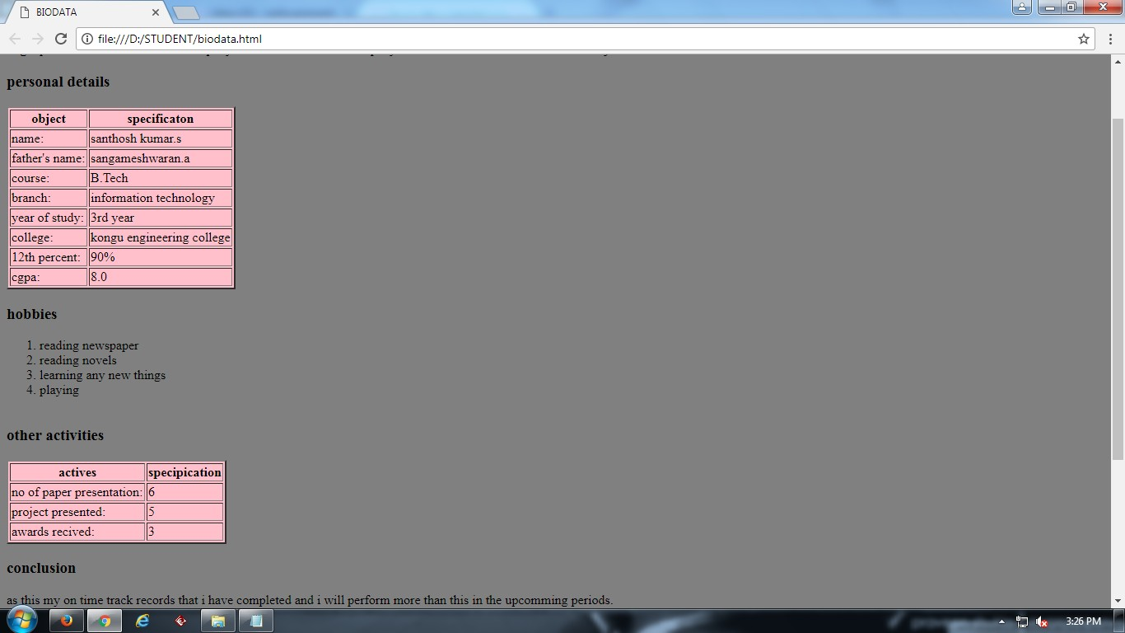

VIVA Questions
- Write a HTML code to display your department name as a heading in different sizes.
- How do you insert a copyright symbol on a browser page?
- Write a HTML document to create links to sections within the same page?
- Create an HTML document containing an ordered list of three items—ice cream, soft serve and frozen yogurt. Each ordered list should contain a nested, unordered list of your favourite flavors. Provide three flavours in each unordered list.

- Create the following table format

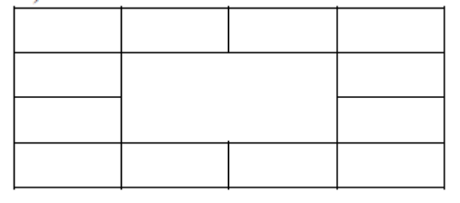

- Write a HTML document to Insert an image and create a link such that clicking on image takes user to other page

- Write an HTML page that contains a selection box with a list of 5 countries
- Create a web page as follows:
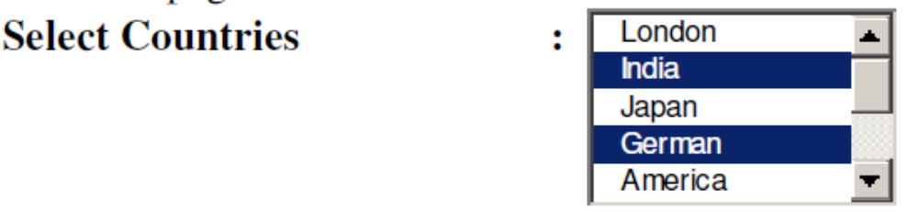The list box should have names of at least 10 countries where 2nd, 4th and 10th country should be selected by default.

- Create a simple search form using a search input element in which the user can enter a search query. Using the Firefox web browser, test the form by entering January and submitting the form. Then enter a J in the input element to see previous entries that started with J—January should be displayed below the input element. Enter June and submit the form again. Now enter a J in the input element to see previous entries that started with J—January and June should be displayed below the input element.

- Create a text input element for a first name. The element should automatically receive the focus when the form is rendered in a browser.

RESULT:
Thus the bio data for the student using the basic table and list tags inHTMLwas successfully designed

EXP: 2 DESIGN OF TOURISM WEBPAGE USING CSS

AIM:

To design the tourism webpage using the css (cascading stylesheet) using simple image
and list tags

DESCRIPTION:

Tag | Description
- <style> | Defines style information for an HTML document
- <link> | Defines a link between a document and an external resource
- <img> | Defines an image
- <map> | Defines an image-map
- <area> | Defines a clickable area inside an image-map
- <ul> | Defines an unordered list
- <ol> | Defines an ordered list
- <li> | Defines a list item
- <dl> | Defines a description list
- <dt> | Defines a term in a description list
- <dd> | Describes the term in a description list

CODING:
<html>
<head>
<link rel="styles.css" type="text/css">
<style> body
{
background-color:#daa520; background-image:url("Logo1.jpg"); background-repeat: repeat-x; background-position: right top;
}
h1
{
background-color: #daa520; color: navy;
margin-left: 20px;
}
p
{
background-color: yellow;
color: red;
}
  - roove
{
border-style: groove; border-color: red;
}
marquee
{
bgcolor=skyblue;
}
</style>
<title>
Welcome to Tamilnadu Tourism
</title>
</head>
<body>

<h1 align="middle"><b><u>Tamil Nadu Tourist</u></b></u></b>
</h1>
<hr>
<br>
<marquee behavior="alternate"><b>Welcome To Tamil Nadu Tourist Places!!!</b></marquee>
<br>
<br>
<figure>
<img src="https://tse4.mm.bing.net/th?id=OIP.M086574b0338f7ef88a2458cb84e13b07o0&pid=15.1 &P=0&w=172&h=167" width=1250>
</figure>
<h2><b><u>Contents:</u></b></h2>
<ol>
<li><a href="#top1">About Tourism</a></li><br>
<li><a href="#top2">About Tamil Nadu</a></li><br>
<li><a href="#top3">Top 12 Hill stations in Tamil nadu</a></li><br>
<li><a href="#top4">Other Places to Visit</a></li><br>
</ol>
<h3 id="top1"><b><u>About Tourism:</u></b></h3>
<img border="2" align="right" src="https://tse3.mm.bing.net/th?id=OIP.Mad6191f440c24e59937beaecd19b63e6H0&pid=15.1" usemap="#img1"/>
<mapname=img1>
<area shape=rect coords=0,0,124,124 href=https://en.wikipedia.org/wiki/Tourism_in_India>
</area>
</map>
<p style="color:blue">Tourism is travel for pleasure; also the theory and practice of touring,
the business of attracting, accommodating, and entertaining tourists, and the business of operating tours.
Tourism may be international, or within the traveler's country. The World Tourism Organization defines tourism more generally,in terms which go "beyond the common perception of tourism as being limited to holiday activity only ",as people "traveling to and staying in places outside their usual environment for not more than one consecutiveyear for leisure, business and other purposes".

Tourism can be domestic or international, and international tourism has both incoming and outgoing implications on a country's balance of payments. Today, tourism is a major source of income for many countries, and affects the economy of both the source and host countries, in some cases being of vital importance.

Tourism suffered as a result of a strong economic slowdown of the late-2000s recession, between the second half of 2008 and the end of 2009, and the outbreak of the H1N1 influenza virus,but slowly recovered. International tourism receipts (the travel item in the balance of payments) grew to US$1.03 trillion (€740 billion) in 2011, corresponding to an increase in real terms of 3.8% from 2010. International tourist arrivals surpassed the milestone of 1 billion tourists globally for the first time in 2012, the same year in which China became the largest spender in international tourism globally with US$102 billion, surpassing Germany and United States.China and emerging markets such as Russia and Brazil had significantly increased their spending over the previous decade.
</p><br>
For more details:-<a href="http://www2.unwto.org/content/why-tourism" target="_blank">Click Here</a><marquee behavior="alternate">Explore More!!!</marquee>
<br><br>
<h3 id="top2"><b><u>About Tamil Nadu:</u></b></h3>
<img border="2" align="left" src="https://tse1.mm.bing.net/th?id=OIP.M4ac5177abfd5bae2558032207000cad1o0&pid=15.1"
><p>
India,officiallytheRepublicofIndia(IAST:BhāratGaṇarājya),isacountryinSouthAsia. It is the seventh-largest country by area, the second-most populous country (with over 1.2 billion people), and the most populous democracy in the world. Bounded by the Indian Ocean on the south, the Arabian Sea on the south-west, and the Bay of Bengal on the south-east, it shares land borders with Pakistan to the west; China, Nepal, and Bhutan to the north-east; and Myanmar (Burma) and Bangladesh to the east.
In the Indian Ocean, India is in the vicinity of Sri Lanka and the Maldives; in addition, India's Andaman and Nicobar Islands share a maritime border with Thailand and Indonesia.<br><br>
Home to the ancient Indus Valley Civilisation and a region of historic trade routes and vast empires, the Indian subcontinent was identified with its commercial and cultural wealth for much of its long history. Four religions—Hinduism, Buddhism, Jainism, and Sikhism—originated here, whereas Zoroastrianism, Judaism, Christianity, and Islam arrived in the 1st millennium CE and also shaped the region's diverse culture. Gradually annexed by and brought under the administration of the British East India Company from the early 18th century and administered directly by the United Kingdom after the Indian Rebellion of 1857, India became an independent nation in 1947 after a struggle for independence that was marked by non-violent resistance led by Mahatma Gandhi.<br><br>

Currently, the Indian economy is the world's seventh-largest by nominal GDP and third-largest by purchasing power parity (PPP). Following market-based economic reforms in 1991, India became one of the fastest-growing major economies; it is considered a newly industrialised country. However, it continues to face the challenges of poverty, corruption, malnutrition and inadequate public healthcare. A nuclear weapons state and a regional power, it has the third-largest standing army in the world and ranks sixth in military expenditure among nations.India is a federal republic governed under a parliamentary system and consists of 29 states and 7 union territories. India is a pluralistic, multilingual, and a multi-ethnic society. It is also home to a diversity of wildlife in a variety of protected habitats.<br><br>
India comprises the bulk of the Indian subcontinent, lying atop the Indian tectonic plate, and part of the Indo-Australian Plate. India's defining geological processes began 75 million years ago when the Indian plate, then part of the southern supercontinent Gondwana, began a north-eastward drift caused by seafloor spreading to its south-west, and later, south and south-east. Simultaneously, the vast Tethyn oceanic crust, to its northeast, began to subduct under the Eurasian plate. These dual processes, driven by convection in the Earth's mantle, both created the Indian Ocean and caused the Indian continental crust eventually to under-thrust Eurasia and to uplift the Himalayas. Immediately south of the emerging Himalayas, plate movement created a vast trough that rapidly filled with river-borne sediment and now constitutes the Indo-Gangetic
Plain. Cut off from the plain by the ancient Aravalli Range lies the Thar Desert.</p><br>

<h3 id="top3"><b><u>Top 12 Hill Staions In Tamil Nadu:</u></b></h3>
<hr>
<img border="2" align="right" src="https://tse2.mm.bing.net/th?id=OIP.Mdc339d31490dc79a9d5652e9f83a58b4o0&w=226&h
=96&c=7&rs=1&qlt=90&o=4&pid=1.1">
<ol>
<li><b>Ooty</b></li>
<p>Among the most popular hill stations in South India is Ooty in Tamil Nadu. Referred to as the 'Queen of Hills', Ooty has been a popular travel destination for many years now. While the main city of Ooty has seen extreme commercialisation, there are pockets that still provide the experience that Ooty was once famous for. Reserved within the deep forests and valleys are
streams that run clear and the fog that envelopes you in a thick blanket. Explore the hidden trails of Ooty to experience the thrilling sight of the Nilgiri Tahr and enjoy unadulterated beauty.<br>
Read more at: <a href="http://nilgiris.nic.in/" target="_blank">Ooty Official</a></p>
<li><b>Yercaud</b></li>
<p>Located in the Shevaroy Hills of Tamil Nadu is another popular hill station, Yercaud. With the surrounding areas being dry, Yercaud provides a pleasant break with its greenery and pleasingweather. The greenery is part natural cover and part plantations. Oranges, coffee, pears, etc are grown in abundance here. The hill station is a popular travel destination in Tamil Nadu and offers various attractions ranging from viewpoints to various waterfalls.<br>
Read more at:<a href="http://www.yercaud.com/" target="_blank">Yercaud Official</a></p>
<li><b>Yelagiri</b></li>
<p>Another popular travel destination among the hill stations in Tamil Nadu is Yelagiri. The quaint hill station is not polluted like the commercial tourist destinations and is rather secluded amidst four mountains. The place is home to several tribal families. The drive to Yelagiri is considered among the highlights of the trip. On road, you will need to climb 14 hairpin bends to reach Yelagiri. The view along the climb is breathtaking.<br>

Read more at:<a href="http://www.tamilnadutourism.org/HillStation/TNHillStations/HS_Yelagiri.aspx">Yelagiri Official</a></p>
<br>
<img border="2" align="left" src="https://tse4.mm.bing.net/th?id=OIP.Mdcbeee56771444b20e2fde8bd25d5f9bo0&w=201&h
=150&c=7&rs=1&qlt=90&o=4&pid=1.1">
<br>
<li><b>Kodaikanal</b></li>
<p>Situated in the upper Palani Hills in Tamil Nadu is another famous hill station, Kodaikanal. Referred to as the 'Princess of Hill Stations', Kodaikanal has much natural beauty to offer for travellers looking to
spend a relaxing vacation. The surrounding hills are sheathed in a thick cover of green, forest trees that maybe a few hundred years old, gurgling streams, pristine lakes and scenic valleys. The place also offers many trekking and rock-climbing trails, a trek to Pillar rocks at a height of 400 ft is a must-do for all who enjoy the outdoors.<br>

Read more at: <a href="http://www.kodaikanal.com/">Kodaikanal Official</a></p>
<li><b>Coonoor</b></li>
<p>Coonoor, situated at a short distance of 17 km from Ooty is another popular tourist destination in Tamil Nadu. At an altitude of 1,850 mt, Coonoor is beautiful with the many tea estates and long-winding roads. Old colonial bungalows in tea estates add to the the charm of Coonoor. The place sees less crowds compared to Ooty, making it more enjoyable.<br>

Read more at:<a href="https://www.tripadvisor.in/Tourism-g297676-Coonoor_Tamil_Nadu- Vacations.html">Trip to Coonoor</a></p>
<img border="2" align="right" src="https://tse3.mm.bing.net/th?id=OIP.Mcbc2175dc1bd31d7de14875ddb533928o0&pid=15.1 &P=0&w=243&h=163">
<li><b>Kotagiri</b></li>
<p>A popular hill station in Tamil Nadu is Kotagiri in the Nilgiris.
At an elevation of 1,793 mt, the hill station is surrounded by green hills and is popular as a trekking destination. While driving to certain destinations, the route via Kotagiri is recommended for the scenic beauty the place offers. The surrounding attractions include; the Dodabetta Range, Catherine Falls, Elk Falls, Rangaswami Pillar, etc.<br>

Read more at:<a href="http://travel.india.com/kotagiri/">Kotagiri Official</a></p>
<li><b>Velliangiri</b></li>
<p>Another important destination in the Nilgiris, situated close to the city of Coimbatore is the Velliangiri Hills. It has earned popularity as the 'Kailasha of the South' for the Shiva Temple present here. Legend goes that Lord Shiva performed the celestial dance at his wife's request at this place. Just 40 km from Coimbatore, Velliangiri Hills is a great option for a one-day and trekking trips.<br>

Read more at:<a href="http://isha.sadhguru.org/blog/inside-isha/happenings/the-velliangiris-a- mountain-of-a-temple/">Velliangiri Hills</a></p>
<li><b>Kolli Hills</b></li>
<p>Located at a short distance of 52 km from Salem city in Tamil Nadu is another hill station that is slowly gaining prominence, Kolli Hills. A tourist destination that is also popular for its approach road which traverses 72 hairpin bends, the place is scenic and cool. Pleasant climate and lesser explored trails in Kolli Hills offers plenty to do in the outdoors.
The hill station also has other attractions such as staying in eco-camps and enjoying the nearby Agaya Gangai waterfalls.<br>
Read more at:<a href="http://www.tamilnadutourism.org/HillStation/Trekking/kollihills.aspx">Kolli Hills</a></p>
<img border="2" align="left" src="https://tse4.mm.bing.net/th?id=OIP.M13d36356fb28c8f9e09b8df891f0bc68H0&w=210&h
=61&c=7&rs=1&qlt=90&o=4&pid=1.1"><br>
<li><b>Anamalai</b></li>
<p>At a short distance of just 14 km from Pollachi is a popular tourist destination in Tamil Nadu, the Anamalai Hills. The hill station is favoured for the salubrious climate it enjoys along with the scenic beauty of the place. Bounded by the rivers Aliar and Uppar, Anamali is another hill station in the Western Ghats also known as Topslip it is popular for the elephant training camp present here. Key attractions include the Anamalai Wildlife Sanctuary.<br>

Read more at:<a href="http://www.holidayiq.com/destinations/anaimalai/">Anamalai Hills</a></p>
<br><li><b>Megamalai</b></li>
<p>Situated in the Theni district of Tamil Nadu, the Meghamalai hill station is also popularby thetag, 'High Wavy Mountains'. It is a lesser known travel destination that consists of many unexplored forests. The beautiful surroundings include cardamom and tea plantations besides the thick forest cover. It is a great place for wildlife enthusiasts and bird watchers as the Megamalai Wildlife Sanctuary located here offers a variety of fauna and flora. Other attractions include tea estate walks and dams.<br>

Read more at:<a href="http://www.megamalai.com/">Megamalai Official</a></p><br><br>
<img border="2" align="right" src="https://tse2.mm.bing.net/th?id=OIP.M8b36818077e5ea87049c31d909835ab9o0&w=175&h
=135&c=7&rs=1&qlt=90&o=4&pid=1.1">
<br><br>
<li><b>Javadi Hills</b></li>
<p>A beautiful travel destination that is largely unexplored is the Javadi Hills in Eastern ghats extension in Tamil Nadu. Covered in lush greenery, especially after the monsoons, the hill station is a nature lover's haven.
Mostly inhabited by tribal communities, the place is located close to the town of Vaniyambadi.
The drive to the place is also considered a memorable experience. Located ideally for a weekend getaway from Chennai or Bangalore, Javadi Hills is a must-visit destination in Tamil Nadu.<br>
Read more at: <a href="http://www.trodly.com/india/destination-5506/javadi-hills">Javadi Hill</a></p>
<li><b>Sirumalai</b></li>
<p>A lesser known hill station of Sirumalai in Tamil Nadu is located at a short distance of25 km from Dindugal and 40 km from Madurai. It is mostly dense forest cover over many small hills. The drive to Sirumalai willtake you across 18 hairpin bends making for a memorable driving experience. Famous attractions in the place include the Mathamalai Annai Veilankanni Churchand various viewpoints from where the city of Dindugal can be seen.<br>

Read more at:<a href="https://www.tripadvisor.in/Attraction_Review-g1023973-d3702734- Reviews-Sirumalai_Reserved_Forest-Dindigul_Tamil_Nadu.html">Sirumalai Hills</a></p>
<br><hr>
<br>
<h3 id="top4"><b><u>Other Places To Visit:</u></b></h3>
<li><b>Monuments at Mahabalipuram</b></li>
<img border="2" src="https://tse3.mm.bing.net/th?id=OIP.M2e2ac18173be4b719f666203eda26897o0&pid=15.1 &P=0&w=249&h=167" align="right" width="1000" height="300" usemap="#img8" />
<map name=img8>
<area shape=rect coords=0,0,82,126 href=img8.jpg target="_blank">
</area>
</map>
<p>This group of sanctuaries, founded by the Pallava kings, was carved out of rock along the Coromandel coast in the 7th and 8th centuries. It is known especially for its rathas (temples in the form of chariots), mandapas (cave sanctuaries), giant open-air reliefs such as the famous 'Descent of the Ganges', and the temple of Rivage, with thousands of sculptures to the glory of Shiva.<br>
For More details Visit<a href="http://whc.unesco.org/en/list/249"> Mahabaliburam monuments</a></p>
<li><b>Vivekananda Rock Memorial</b></li>
<img src="https://tse4.mm.bing.net/th?id=OIP.Mdc65758aeeede4cf14682cfb2f1072e9o0&pid=15.1& P=0&w=272&h=182" align="right" width="500" height="300">
<p>Swami Vivekananda has said that even after he laid down his body, he would continue to work and inspire generations to come to carry on his unfinished work.We see it still happing. Swamiji does it in innumerable ways. The magnificent Vivekananda Rock Memorial at Kanyakumari is one such undying source of inspiration.

The Vivekananda Memorial, as it stands today, is a memorial to Swamiji as to Shri Ekanthji Ranade whose devotion to the work he had undertaken was inspired not by mere faith but by intellectual conviction.
At Kanyakumari - a unique symbol of unity and purity - is the Memorial of Swami Vivekananda, another symbol of the united aspiration of Nation. In the Memorial, there is a happy and harmonious blend of all the architectural beauty of the country. It is a symbol of unity because the whole nation wished, worked and contributed for it. Person from all states participated in its inauguration. It is also a Memorial, conceived and laboured for mainly by RSS swayamsevaks, blessed by Ramakrishna Mission, designed by Paramacharya of Kachi Kamakoti Peetham, and for which Swami Chinmayananda of Chinmay Mission gave the first donation.All the spiritual,culture and national organisations supported it.It is also a Memorial for which all State Governments and Central Government contributed.
Thus, the memorial became a focal point just as Kanyakumari is a meeting point for three seas.

Inaugurating the Rock Memorial on September 2, 1970, the President of India Shri V.V. Giri called upon fellow Indians to rise to the call of the nation.

Eknathji described beautifully uniqueness of Kanayakumari in his one speech in 1966.He gave the series of inspiring speeches on Vivekananda Rock Memorial to the first batch of Workers of Vivekananda Kendra which helped to clear idea behind VRM (Vivekananda Rock Memorial) and VK (Vivekananda Kendra).<br>For More Details <a href="http://www.vivekanandakendra.org/english/vivekananda-rock-memorial">-Click Here</a><p>
<li><b>Dhanushkodi Beach</b></li>
<img src="https://tse3.mm.bing.net/th?id=OIP.Md5038885dbd44c5c181f4264da4f67e5o0&pid=15.1 &P=0&w=275&h=183" align="left" width="500" height="200" usemap="#img11">
<map name=img11>
<area shape=rect coords=0,0,125,125 href=https://en.wikipedia.org/wiki/Dhanushkodi>
</area>
</map>
<p>50 years after a cyclone wiped it out, Dhanushkodi is slowly finding its feet. A tourist attraction precisely for its desolateness, road connectivity could soon transform it. Saisuresh Sivaswamy, who spent a few hours there, comes back enchanted.As the doughty, packed to the gills Mahindra 4WD vehicle bounces along the tracks left by others of its ilk, along the undulating sand dunes leading up to the seaside, you strain your eyes to see the desolate yet mesmerising sights outside.
</ol>
</body>
</html>

OUTPUT:
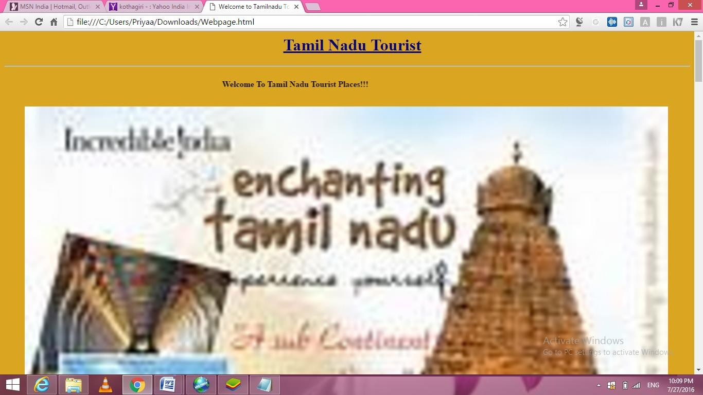

Viva Questions
- Give an example for pseudo class.
- Consider the following HTML/CSS code:

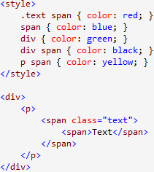
What color will be applied to the text?
- Display image and a text overlapping on each other.
- Demonstrate the difference between visibility: hidden and display:none.
- Name three ways to define a color in html.
- How to create a scrollable content?
- Write CSS Script to make an image remain in place when the user scrolls up or down.
- Write a CSS rule that changes the color of all elements containing attribute class = "green-Move" to green and shifts them down 25 pixels and right 15 pixels.
- Create two paragraphs and line them as columns side by side.
- Create a rule that displays all links in blue without underlining them.

RESULT:
Thus the tourism webpage using the css (cascading stylesheet) and by using simple image and list tag was designed

EXP: 3

CREATION OF LIBRARY MANAGEMENET WEBSITE USING MENU LAYOUT AIM:
To create a library management website using menu layout

DESCRIPTION:
- background-color | Specifies the background color to be used
- background-image | Specifies ONE or MORE background images to be used
- background-position | Specifies the position of the background images
- background-size | Specifies the size of the background images
- background-repeat | Specifies how to repeat the background images
    - Τεξτ−αλιγν αλιγνσ τηε τεξτ το τηε γιϖενποσιτιον
- Display:inline | Default value. Displays an element as an inline element
- Display:Block | Displays an element as a block element
- :hover | This selector is used to select elements when you mouse over
- Div | Used to define the division

CODING: LIBRARY.CSS:
body{
background-color:grey; background-image:url("/l5.jpg");} h1{
background-color:red; text-align:center;}
p{
text-align:left;
font-family:LiberationSerif; font-size:1em;
}
img{
position:top right; height:300; width:500:
}

MENU HTML:

<html>
<head>
<link rel=stylesheet type=text/css href=lib.css>
<style> div{
background-color:white; padding:2px 30px; margin:1;
text-align:center; float:left;} div.books:hover a{ background-color:pink; display:block; padding:5px 30px;
}
div.books a{ display:none; color:block; text-align:center margin:1;
padding:2px 30px;
}
div.books a:hover{background-color:yellow;} div.news:hover a{
background-color:pink; display:block; margin:1;
}
div.news a{ display:none; color:block; margin:1;
text-align:center; padding:2px 30px;
}
div.news a:hover{background-color:yellow;} div.reference a{
display:none; color:block; margin:1;
text-align:center; padding:2px 30px;
}
div.reference:hover a{
background-color:pink; display:block; margin:1; }
div.reference a:hover{background-color:yellow;} div.help:hover a{
background-color:pink; display:block; margin:1;
}
div.help a{ display:none; color:block; margin:1;
text-align:center; padding:2px 30px;
}
div.help a:hover{background-color:yellow;}
</style>
</head>
<body>
<h1><em>Library Website</em></h1>
<div class="books">books
<a href="file:///home/student/14itr080/sub.html">subject</a>
<a href="file:///home/student/14itr080/pro.html">projects</a>
<a href="#">papers</a>
</div>
<div class="news">news
<a href="file:///home/student/14itr080/mag.html">magazine</a>
<a href="#">papers</a>
<a href="#">websites</a>
</div>
<div class="reference">reference
<a href="#">books</a>
<a href="#">sites</a>
<a href="#">journals</a>
</div>
<divclass="help">help
<ahref="#">about</a>
<a href="file:///home/student/14itr080/login.html">login</a>
<a href="#">register</a>
</div>
<br>
<br><br><br><br><br><br><br><br><br>
<img src="/home/student/14itr080/l1.jpg"></img>
<br>
<br><br><br><br>
<p><i>this website provides the library management service in the library.</i></p>
</body>
</html>

MAGAZINES HTML:

<html>
<head>
<title>MAGAZINES</title>
<link rel=stylesheet type=text/css href=lib.css>
<style> div{
background-color:white; padding:2px 30px; margin:1;
text-align:center; float:left;} div.mainprojects:hover a{ background-color:pink; display:block; padding:5px 30px;
}
div.mainprojects a{ display:none; color:block;
text-align:center margin:1; padding:2px 30px;
}
div.mainprojects a:hover{background-color:yellow;} div.miniprojects:hover a{
background-color:pink; display:block; padding:5px 30px;
}
div.miniprojects a{ display:none; color:block;
text-align:center margin:1; padding:2px 30px;
}
div.miniprojects a:hover{background-color:yellow;}
</style>
</head>
<body>

<h1><em>Magazines</em></h1>
<div class="mainprojects">technical
<a href="#">mechanical</a>
<a href="#">mechotronics</a>
<a href="#">computer science</a>
<a href="#">civil</a>
<a href="#">electronics</a>
</div>
<div class="miniprojects">non technical
<a href="#">mechanical</a>
<a href="#">mechotronics</a>
<a href="#">computer science</a>
<a href="#">civil</a>
<a href="#">electronics</a>
</div><br><br><br><br><br><br><br><br><br>
<p><i>this page provides the list of magazines based on the department that you need.and you can select the magazines which you want.
<img src="/home/student/14itr080/l3.jpg"></img>so that others won't book that.</i></p>
</body>
</html>

PROJECTS HTML:

<html>
<head>
<title>PROJECTS</title>
<link rel=stylesheet type=text/css href=lib.css>
<style> div{
background-color:white; padding:2px 30px; margin:1;
text-align:center; float:left;} div.mainprojects:hover a{ background-color:pink; display:block; padding:5px 30px;
}
div.mainprojects a{ display:none; color:block;
text-align:center margin:1; padding:2px 30px;
}
div.mainprojects a:hover{background-color:yellow;} div.miniprojects:hover a{
background-color:pink; display:block; padding:5px 30px;
}
div.miniprojects a{ display:none; color:block;
text-align:center margin:1; padding:2px 30px;
}
div.miniprojects a:hover{background-color:yellow;}
</style>
</head>
<body>
<h1><em>Projects</em></h1>
<div class="mainprojects">main projects
<a href="#">mechanical</a>
<a href="#">mechotronics</a>
<a href="#">computer science</a>
<a href="#">civil</a>
<a href="#">electronics</a>
</div>
<div class="miniprojects">mini projects
<a href="#">mechanical</a>
<a href="#">mechotronics</a>
<a href="#">computer science</a>
<a href="#">civil</a>
<a href="#">electronics</a>
</div>
<br><br><br><br><br><br><br><br><br><br>
<p><i>this page provides the list of project that you need.and you can select and projects the books which you want. so that others won't book that.</i></p>
</body>
</html>

SUBJECTS HTML:

<html>
<head>
<title>subjects</title>
<link rel=stylesheet type=text/css href=lib.css>
<style>
div{
background-color:white; padding:2px 30px; margin:1;
text-align:center; float:left;} div.department:hover a{ background-color:pink; display:block; padding:5px 30px;
}
div.department a{ display:none; color:block;
text-align:center margin:1; padding:2px 30px;
}
div.department a:hover{background-color:yellow;} div.magazines:hover a{
background-color:pink; display:block; padding:5px 30px;
}
div.magazines a{ display:none; color:block;
text-align:center margin:1; padding:2px 30px;
}
div.magazines a:hover{background-color:yellow;} div.author:hover a{
background-color:pink; display:block; padding:5px 30px;
}
div.author a{ display:none; color:block; text-align:center margin:1;
padding:2px 30px;
}
div.author a:hover{background-color:yellow;}
</style>
</head>
<body>
<h1><em>Books</em></h1>
<div class="department">course
<a href="#">mechanical</a>
<a href="#">mechotronics</a>
<a href="#">computer science</a>
<a href="#">civil</a>
<a href="#">electronics</a>
</div>
<div class="author">author
<a href="#">mechanical</a>
<a href="#">mechotronics</a>
<a href="#">computer science</a>
<a href="#">civil</a>
<a href="#">electronics</a>
</div>
<div class="magazines">magazines
<a href="#">mechanical</a>
<a href="#">mechotronics</a>
<a href="#">computer science</a>
<a href="#">civil</a>
<a href="#">electronics</a>
</div><br><br><br><br><br><br><br><br><br><br>
<p><i>this page provides the books that you need.and you can select and book the books which you want. so that others won't book that.</i></p>
</body>
</html>

LOGIN HTML:

<html>
<head>
<title>LOGIN PAGE</title>
<link rel=stylesheet type=text/css href=lib.css>
</head>
<body>
<h1><em>Login</em></h1>
<form>
Register Number
<input type="text" name="Register Number" placeholder="enter the rollno" required><br> Passward:
<input type="text" name="Passward" placeholder="enter the passward" required><br>
<br>
<input type="submit" name="Enter" value="Enter"><br>
</form>
</body>
</html>

OUTPUT:
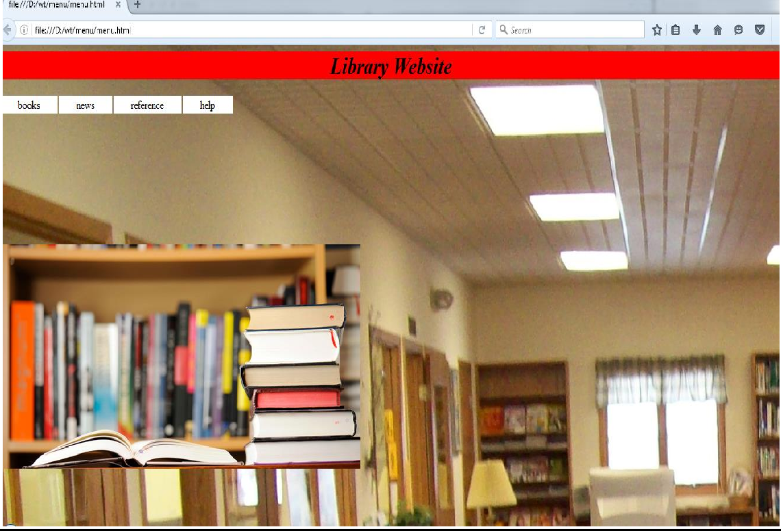

Viva Questions
- How to sets all the border properties in one declaration?
- Create a dropdown menu as given below
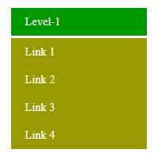
- Create a dropdown menu that allows the user to choose an option from a list
- Write a CSS property to display drop-down content on the right screen.
Example:

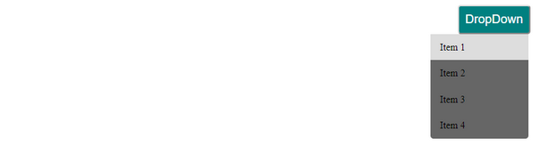
- Set the color for unvisited links to "red", and the color for visited links "blue".
- Create a CSS file to add a dropdown menu inside a navigation bar.
- What happens if the list-style-type property is used on a non-list element like a paragraph?
- How block elements can be centered with CSS?
- How do margin, border and padding fit together in the box model
- Position the <h1> element relative to the browser window. 50px from the top, and 50px from the right.
<html>
<head>
<style>
h1 {
color: red;
................
}
</style>
</head>
<body>

<h1>This is a Heading</h1>
<p>This is a paragraph.</p>
<p>This is another paragraph.</p>

</body>
</html>

RESULT:
Thus library management website was created using menu layout and the output was verified.
EXP: 4

DESIGN A REGISTRATION PAGE TO CREATE EMAIL-ID AND VALIDATE THE INFORMATION IN THE WEB PAGE USING JAVA SCRIPT

AIM:
To design a registration page to create email-id and validate the information in the web page using Java Script

DESCRIPTION:
    - A regular expression is an object that describes a pattern ofcharacters.
    - When you search in a text, you can use a pattern to describe what you are searchingfor.
    - A simple pattern can be one single character.
    - A more complicated pattern can consist of more characters, and can be used forparsing, format checking, substitution andmore.
    - Regular expressions are used to perform powerful pattern-matching and"search-and- replace" functions ontext.
    - Syntax : var patt=new RegExp(pattern,modifiers);(or) varpatt=/pattern/modifiers;
    - In this form validation for first name,last name,zipcode,phone number,email id and password areperformed

CODING:
form.html
<html>
<head><title>form 3</title>
<script type="text/javascript"> function validateForm() {
var ck_zipcode=/(^\d{6}$)|(^\d{6}-\d{5}$)/; var x = document.myForm.fname.value;
var y = document.myForm.lname.value; var p=document.myForm.password.value; varrp=document.myForm.rpassword.value;
var country =document.myForm.country.value; var email=document.myForm.email.value;
var gender=document.myForm.gender.value; var zipcode=document.myForm.zipcode.value; var check=document.myForm.check.value;
var errors = [];
if (x == null || x=="") {
errors[errors.length]= "First-Name must be filled out";
}
if (y == null || y == "") {
errors[errors.length] ="Last-Name must be filled out";
}
if (email == null || email == ""){
errors[errors.length] ="you must enter the email address";
}
if (p == null || p == "") {
errors[errors.length]= "You didn't enter a password.";
}
else if(p.length < 8){
errors[errors.length]="The Password should be 8 charachter.";} if(p != rp)
errors[errors.length]="Passwords Do not match";
if ( ( myForm.gender.checked == 0 ) && ( myForm.gender.checked == 1 ) )
{
errors[errors.length] ="Please choose your Gender: Male or Female";
}
if (country==0) {
errors[errors.length] ="Select Country";
}
if (zipcode == null || zipcode == "") {
errors[errors.length]= "You didn't enter a zipcode.";
}
if (!ck_zipcode.test(zipcode)) {
errors[errors.length] ="Please provide a zip in the format ######.";
}
if (myForm.check.checked == 0){ errors[errors.length]="agree the terms and condition";}
if (errors.length > 0) { reportErrors(errors); return false;
}
return true;
}
function reportErrors(errors){
var msg = "Please Enter Valide Data...\n"; for (var i = 0; i<errors.length; i++) {
var numError = i + 1;
msg += "\n" + numError + ". " + errors[i];
}
alert(msg);
}
</script>
</head>
<body>
<center>
<h1>FORM Validation</h1>
<br><br><br>
<form name="myForm" action=" " onsubmit="return validateForm()" >
FIRST-NAME: <input type="text" name="fname" placeholder="First name"><br><br>
LAST-NAME: <input type="text" name="lname" placeholder="Last name"><br><br>EMAIL:<input type="email" name="email" Pattern = "[a-z0-9._%+-]+@[a-z0-9.-]+\.[a- z]{2,3}$" placeholder="E-Mail"><br><br>
PASSWORD:<input type="password" id="password"placeholder="Password"><br><br> CONFIRM-PASSWORD:<input type="password"id="rpassword"
placeholder="Confirm-Password"><br><br>
GENDER: <input type="radio" name="gender" value="Male"> Male
<input type="radio" name="gender" value="Female">Female<br><br>
COUNTRY:<selectid="country" name="country">
<option value="0">Country</option><option value="1">Afganisthan</option><option value="2">Albania</option> <option value="3">Brazil</option> <option value="4">Canada</option>
<option value="5">India</option> <option value="6">Japan</option>
<option value="7">Latvia</option> <option value="8">Mauritius</option>

<option value="9">United Kingdom</option> <option value="10">United States</option>
</select><br><br>
ZIP-CODE:<input type="text" id="zipcode" name="zipcode" ><br><br>
<input type="checkbox" id="check"> I agree the terms and condition <br><br>
<input type="submit" value="Submit">
</form>
</body>
</html>

OUTPUT:
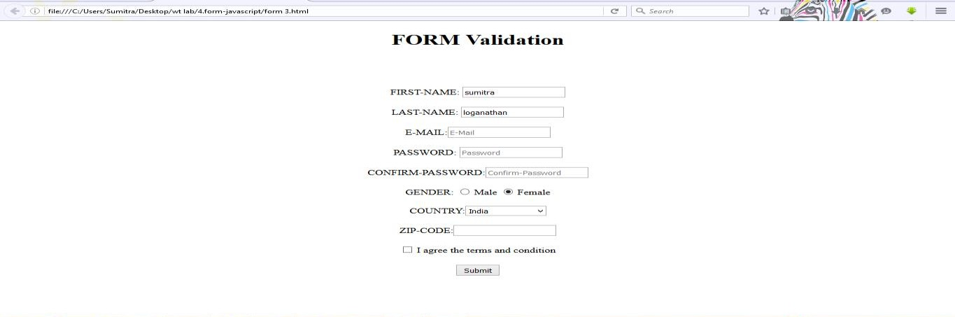
Viva Questions
- Demonstrate the difference between == and = = = with an example.
- How can you change the value of an HTML input element using javascript.
- What would be the result of 3+2+”7”.
- Get the marks of the subjects for the current semester and store it in an array.
- Validate the marks obtained in Question 4. (Marks should be 0 to 100).
- How to embed the external javascript file into the HTML document?
- What is the difference between undefined value and NULL value?
- Write a JavaScript to get the name and roll no. of a student and display it as an alert message.
- Write a script that calculates the squares and cubes of the numbers from 0 to 5 and display the result as show below.
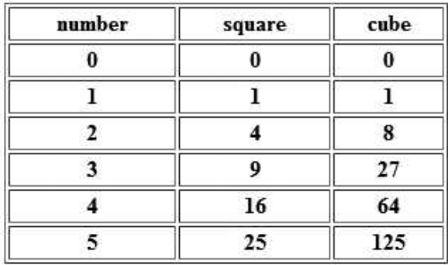

- Write a script that inputs three numbers and displays the number of negative numbers, positive numbers and zeros input.
RESULT:
Thus a registeration form to create email id was created and validation was performed using javascript.

EXP: 5

JAVASCRIPT PROGRAM USING OBJECTS AND COLLECTIONS

AIM:
To write a JavaScript program to use Objects and Collections

DESCRIPTION:
    - <form>Element:
The HTML <form>element defines a form that is used to collect user input. Form elements are different types of input elements, like text fields, checkboxes, radio buttons, submit buttons, and more.

JavaScript:
A JavaScript function is placed in the <head> section of an HTML page. The function is invoked (called) when a button is clicked..
    - JavaScriptFunctions:
A JavaScript function is a block of code designed to perform a particular task. A JavaScript function is executed when "something" invokes it.

HTML DOM Nodes
HTML DOM (Document Object Model), everything is a node:
    - The document itself is a documentnode
    - All HTML elements are elementnodes
    - All HTML attributes are attributenodes
    - Text inside HTML elements are textnodes
    - Comments are comment nodes

Property / Method | Description
document.createAttribute() | Creates an attribute node
document.createComment() | Creates a Comment node with the specified text
document.createDocumentFragment() | Creates an empty DocumentFragment node
document.createElement() | Creates an Element node
document.createTextNode() | Creates a Text node
document.doctype | Returns the Document Type Declaration associated with the document
document.documentElement | Returns the Document Element of the document (the <html> element)
document.forms | Returns a collection of all <form> elements in the document
document.getElementById() | Returns the element that has the ID attribute with the specified value
document.getElementsByName() | Returns a NodeList containing all elements with a pecified name
document.write() | Writes HTML expressions or JavaScript code to a document
document.writeln() | Same as write(), but adds a newline character after each statement

CODING: DOMOBJECTS:
<html>
<body>
<ul id="List">
<li>webtech</li>
<li>Networking</li>
</ul>
<p>click here to insert before the element</p><br>
<button onclick="myfn()">INSERTBEFORE</button>
<p>click here to removethe element</p><br>
<button onclick="myFunction()">REMOVE</button>
<p>click here to append theelement</p><br>
<buttononclick="obj1()">APPEND</button>
<p>click here to replace theelement</p><br>
<button onclick="myFunction3()">REPLACE</button><br>
<script> functionmyfn()
{
varnewItem = document.createElement("li"); vartextnode = document.createTextNode("java"); newItem.appendChild(textnode);
var list = document.getElementById("List"); list.insertBefore(newItem, list.childNodes[0]);
}
functionmyFunction() {
var list = document.getElementById("List"); list.removeChild(list.childNodes[0]);
}
function myFunction3() {
vartextnode = document.createTextNode("artificial intelligence");
var item = document.getElementById("List").childNodes[0];
item.replaceChild(textnode, item.childNodes[1]);
}
</script>
</body>
</html>

OUTPUT:
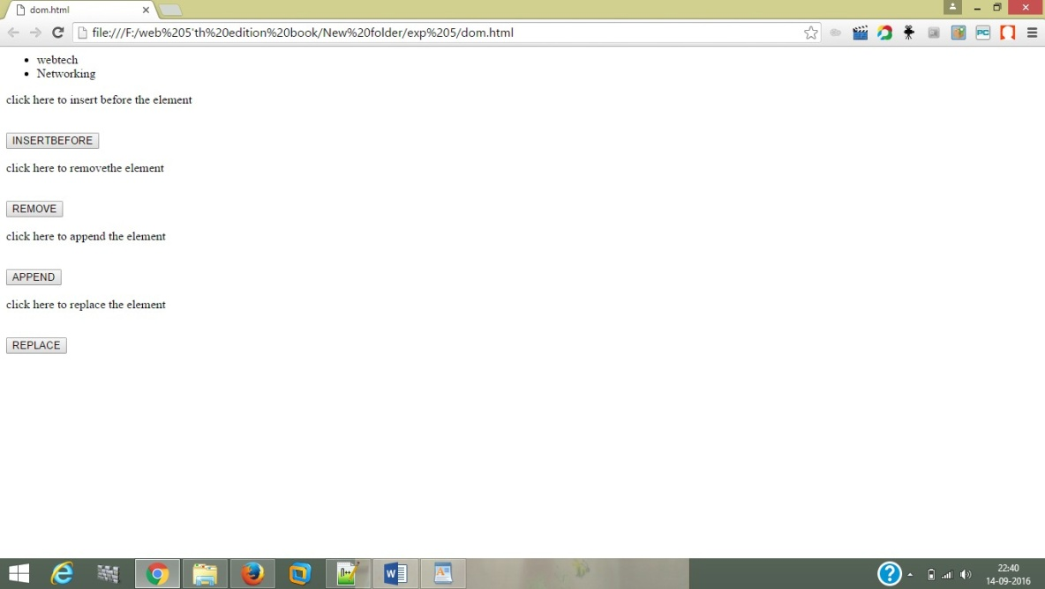

DOM COLLECTIONS:

<html>
<body>
<form id="myform">
<input type="text" id="6" value="enter name"></br>
<input type=password" value="enter password"></br>
<a href="/html/default.asp">click here</a><br>
<a id="2" href="/css/default.asp">try it</a>
<a id="3">anchor</a>
</form>
<button onclick="myFunction()">no of forms</button><br>
<p id="p1"></p>
<button onclick="myFunction2()">click no of form elements</button><br>
<p id="p2"></p>
<button onclick="indexs()">index property</button><br>
<p id="p3"></p>
<button onclick="itemindex()">itemindex</button><br>
<p id="p4"></p>
<button onclick="nameditems()">nameditemproperty</button><br>
<p id="p5"></p>
<script> functionmyFunction() {
var x = document.forms.length; document.getElementById("p1").innerHTML = x;
}
function myFunction2() {
var x = document.getElementById("myform").elements.length; document.getElementById("p2").innerHTML = "Found " + x + " elements in the form.";
}
functionindexs()
{
var y = document.forms[0].id; document.getElementById("p3").innerHTML = y;
}
functionitemindex()
{
var u = document.forms.item(0).id; document.getElementById("p4").innerHTML = u;
}
functionnameditems()
{
var k = document.forms.namedItem("myform").innerHTML; document.getElementById("p5").innerHTML =k;
}
</script>
</body>
</html>
<html>
<body>
<p>
<a href="/html/default.asp">click here</a><br>
<a href="/css/default.asp">try it</a>
<a id="3"</a>
</p>
<button onclick="myFunction()">no of links</button><br>
<p id="p1"></p>
<button onclick="myFunction2()">click no of p tags</button><br>
<p id="p2"></p>
<button onclick="indexs()">index property</button><br>
<p id="p3"></p>
<button onclick="nameditems()">nameditemproperty</button><br>
<p id="p4"></p>
<script> functionmyFunction()
{ var x=document.links.length; document.getElementById("p1").innerHTML = x;
}
function indexs(){
var y = document.links[0].href; document.getElementById("p3").innerHTML = y; var w=document.links.namedItem("3").href;
}
function nameditems()
{
var k = document.links.namedItem("myLink").href; document.getElementById("p4").innerHTML =k;
}
function myFunction2() {
varnodelist = document.getElementsByTagName("P").length; document.getElementById("p2").innerHTML = nodelist;
}
</script>
<body>
<p>
<a id="2" name="try it">try it</a>
<a id="3" name="anchor">anchor</a>
</p>
<button onclick="myFunction()">no of anchor tags</button><br>
<p id="p1"></p>
<button onclick="myFunction2()">click no of p tags</button><br>
<p id="p2"></p>
<button onclick="indexs()">index property</button><br>
<p id="p3"></p>
<button onclick="itemindex()">itemindex</button><br>
<p id="p4"></p>
<button onclick="nameditems()">nameditemproperty</button><br>
<p id="p5"></p>
<script> functionmyFunction() {
var x = document.anchors.length; document.getElementById("p1").innerHTML = x;
}
function myFunction2() {
varnodelist = document.getElementsByTagName("P").length; document.getElementById("p2").innerHTML = nodelist;}
functionindexs(){
var y = document.anchors[0].innerHTML; document.getElementById("p3").innerHTML = y;}
functionitemindex(){
var u = document.anchors.item(0).innerHTML; document.getElementById("p4").innerHTML = u;}
functionnameditems(){
var k = document.anchors.namedItem("3").innerHTML; document.getElementById("p5").innerHTML =k;}
</script>
</body>
</html>
<html>
<body>
<imgsrc="C:\Users\nandhu\Pictures\12bg.jpg" id="myimg" alt="flower" width="150" height="113">
<imgsrc="C:\Users\nandhu\Pictures\TH.jpg" alt="flower" width="152" height="128">
<imgsrc="C:\Users\nandhu\Pictures\kris.jpg" alt="Smiley face" width="42" height="42">
<button onclick="myFunction()">no of image tags</button><br>
<p id="p1"></p>
<button onclick="myFunction2()">click no of p tags</button><br>
<p id="p2"></p>
<button onclick="indexs()">index property</button><br>
<p id="p3"></p>
<button onclick="itemindex()">itemindex</button><br>
<p id="p4"></p>
<button onclick="nameditems()">nameditemproperty</button><br>
<p id="p5"></p>
<script> functionmyFunction() {
var x = document.images.length; document.getElementById("p1").innerHTML = x;
}
function myFunction2() {
varnodelist = document.getElementsByTagName("P").length; document.getElementById("p2").innerHTML = nodelist;
}
functionindexs()
{
var y = document.images[0].src; document.getElementById("p3").innerHTML = y;
}
functionitemindex()
{
var u = document.images.item(1).src; document.getElementById("p4").innerHTML = u;
}
functionnameditems()
{
var k = document.images.namedItem("myimg").src; document.getElementById("p5").innerHTML =k;
}
</script>
</body>
</html>

OUTPUT:
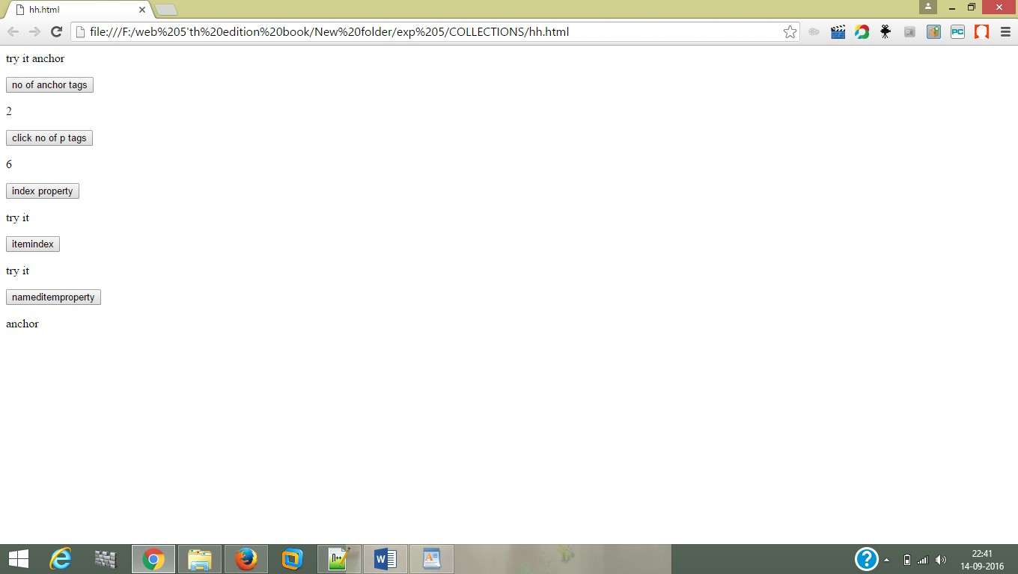

Viva Questions
- If we want to return the character from a specific index which method is used?
- Write the code for adding new elements dynamically?
- How can the style/class of an element be changed?
- Here is a sample html file with a button. Now modify the style of the paragraph text when the button is clicked.
<html>
<head>
<meta charset=utf-8 />
<title>JS DOM paragraph style</title>
</head>
<body>
<p id ='text'>JavaScript Exercises - w3resource</p>
<div>
<button id="jsstyle"
onclick="js_style()">Style</button>
</div>
</body>
</html>
- Here is a sample html file with a button. Write a JavaScript function to get the value of the href, hreflang, rel, target, and type attributes of the specified link.
<html><head>
<meta charset=utf-8 />
</head>
<body>
<p><a id="w3r" type="text/html" hreflang="en-us" rel="nofollow" target="_self" href="https://www.w3resource.com/">w3resource</a></p>
<button onclick="getAttributes()">Click here to get attributes value</button>
</body></html>

- Alert "John" by extracting information from the person object.

var person = {firstName: "John",lastName: "Doe"};
alert (_____________);
- Use the correct Date method to extract the year (four digits), month (0-11) out of a date object.
var d = new Date();
year= ___________;
month=___________;

- Write a JavaScript function named Extract() to display the word "bananas" from the given text.
"I can eat bananas all day"

- Use the correct Date method to set the year of a date object to 2020.

- Write a JavaScript function that takes a string which has lower and upper case letters as a parameter and converts upper case letters to lower case, and lower case letters to upper case

RESULT:

Thus the javascript program using DOM and Collections was created

EXP: 6

DESIGN A WEB PAGE TO CREATE SIMPLE INTERACTIVE CGPA CALCULATOR

AIM:
To design a webpage to create simple CGPA calculator using Java Script

DESCRIPTION:

    - <form>Element:
The HTML <form>element defines a form that is used to collect user input. Form elements are different types of input elements, like text fields, checkboxes, radio buttons, submit buttons, and more.

<input>Element:
The <input>element is the most important form element. The <input> element can be displayed in several ways, depending on the type attribute.

Type | Description
<input type="text"> | Defines a one-line text input field
<input type="radio"> | Defines a radio button (for selecting one of many choices)
<input type="submit"> | Defines a submit button (for submitting the form)

JavaScript:
A JavaScript function is placed in the <head> section of an HTML page. The function is invoked (called) when a button is clicked.

JS OutputStatements:
- Using document.write() after an HTML document is fully loaded, will delete all existing HTML. The document.write() method should only be used for testing. Syntax:
document.write(exp1, exp2, exp3, ...)
⇒exp1, exp2, exp3, … Optional. What to write to the output stream.
- The Window.alert()method displays an alert dialog with the optional specified content and an OKbutton

Syntax:
window.alert(message);
⇒message is an optional string of text, an object that is converted into a string and displayed
- Document.formname.variablename.value – Returns the value which hasthe variablename same as name in theform.

JavaScriptFunctions:
A JavaScript function is a block of code designed to perform a particular task. A JavaScript function is executed when "something" invokes it.

CODING:
<html>
<head>
<title>CGPA Calculation</title>
<script type="text/javascript"> function calculate()
{
var gpa=0,totcred=0,cgpa=0; var c=new Array(10);
var g=new Array(10); c[0]=parseInt(document.myForm.c1.value); g[0]=document.myForm.g1.value; c[1]=parseInt(document.myForm.c2.value); g[1]=document.myForm.g2.value; c[2]=parseInt(document.myForm.c3.value); g[2]=document.myForm.g3.value; c[3]=parseInt(document.myForm.c4.value); g[3]=document.myForm.g4.value; c[4]=parseInt(document.myForm.c5.value); g[4]=document.myForm.g5.value; c[5]=parseInt(document.myForm.c6.value); g[5]=document.myForm.g6.value; c[6]=parseInt(document.myForm.c7.value); g[6]=document.myForm.g7.value; c[7]=parseInt(document.myForm.c8.value); g[7]=document.myForm.g8.value; c[8]=parseInt(document.myForm.c9.value); g[8]=document.myForm.g9.value; c[9]=parseInt(document.myForm.c10.value); g[9]=document.myForm.g10.value; for(i=0;i<10;i++)
{
var gp=new Array(10); var t=0; for(i=0;i<10;i++)
{
if(c[i]<3||c[i]>4)
{
alert( "Please provide your credit 3 or 4!" ); return false;
}
if(g[i]==""||isNaN(g[i])==false)
{
alert( "Please provide your grade in Captial letters for subject"+(i+1)); return false;
}
if((g[i]!="S")&&(g[i]!="A")&&(g[i]!="B")&&(g[i]!="C")&&(g[i]
!="D")&&(g[i]!="E")&&(g[i]!="RA"))
{
alert( "Please provide your grades as S,A,B,C,D,E or RA!" ); return false;
}
}

if(g[i]=='RA')
{
t=1;
break;
}
switch(g[i])
{

}
}
if(t==1) cgpa=0; else
{
case 'S':
gp[i]=10; break;
case 'A':
gp[i]=9; break;
case 'B':
gp[i]=8; break;
case 'C':
gp[i]=7 break;
case 'D':
gp[i]=6; break;
case 'E':
gp[i]=5; break;

for(i=0;i<10;i++)
{
gpa=gpa+c[i]*gp[i]; totcred=totcred+c[i];
}
alert("gpa="+gpa); alert("totcred="+totcred);
cgpa=gpa/totcred;
}
alert("CGPA="+cgpa); document.myForm.gpa.value=gpa; document.myForm.cgpa.value=cgpa; document.myForm.totcred.value=totcred;
}
</script>
</head>
<body>
<center>
<h1><font color=red>CGPA Calculation</font></h1><hr>
<form name="myForm">
<h3><p>Name<input type="text" name="Name"/></p><p>Rollnumber<input type="text" name="rno"/></p><p>Department<input type="text" name="dept"/></p></h3>
<h3><label>Credits Grade</label></h3><br>
<p><label>Subject1</label><input type="text" name="c1"/><inputtype="text" name="g1"/></p>
<p><label>Subject2</label><input type="text" name="c2"/><inputtype="text" name="g2"/></p>
<p><label>Subject3</label><input type="text" name="c3"/><inputtype="text" name="g3"/></p>
<p><label>Subject4</label><input type="text" name="c4"/><inputtype="text" name="g4"/></p>
<p><label>Subject5</label><input type="text" name="c5"/><input type="text" name="g5"/></p>
<p><label>Subject6</label><input type="text" name="c6"/><inputtype="text" name="g6"/></p>
<p><label>Subject7</label><input type="text" name="c7"/><inputtype="text" name="g7"/></p>
<p><label>Subject8</label><input type="text" name="c8"/><inputtype="text" name="g8"/></p>
<p><label>Subject9</label><input type="text" name="c9"/><inputtype="text" name="g9"/></p>
<p><label>Subject10</label><input type="text" name="c10"/><input type="text" name="g10"/></p>
<p><label>GPA</label><input type="text" name="gpa"/></p>
<p><label>TotCred</label><input type="text" name="totcred"/></p>
<p><label>CGPA</label><input type="text" name="cgpa"/></p>
<p><input type="button" name="Calculate" onclick="calculate()">
</center>
</form>
</body>
</html>

OUTPUT:

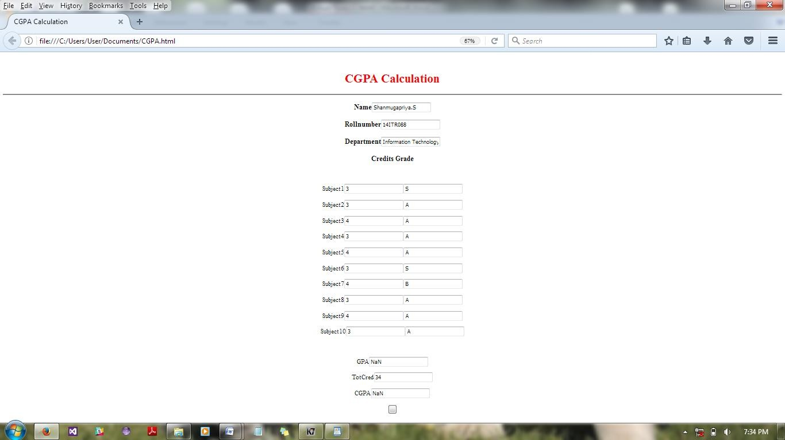

Viva Questions

- Demonstrate Event Bubbling with an example.
- Write a code to display the element on which the event has occurred and the type of the event.
- Write a function that responds to a click event anywhere on the page by displaying an alert dialog.
- Name three events that are when the mouse.
- Once the user finish typing the name and move to next element the username should be validated. Perform this operation using event handling
- The state of three keys can be retrieved by using the event object. Name these keys.
- Write javascript to display number of seconds you have spent in viewing that page using Date object.
- The following example uses what type of function to handle an event?
element.addEventListener('click', function(event){});
- When hovering the mouse pointer over the element, its children should produce an alert message. Write a script to do this task.
- Write a script to display some help information corresponding to that element in one specific location whenever an element get focused.

RESULT:

Thus the CGPA calculator was designed using JavaScript

EXP: 7

RETRIEVING NAME OF USER USING AJAX IN PHP

AIM:
To retrieve the name of the user using ajax in php.

ALGORITHM:
First, check if the input field is empty (str.length == 0). If it is, clear the content of the txtHint placeholder and exit the function.
However, if the input field is not empty, do the following:

    - Create an XMLHttpRequestobject
    - Create the function to be executed when the server response isready
    - Send the request off to a PHP file (gethint.php) on theserver
    - Notice that q parameter is added to the url(gethint.php?q="+str)
    - And the str variable holds the content of the inputfield
    - XMLHttpRequest() - Request data fromserver.
    - Xmlhttp.onrreadystatechange- Defines a function to be called when the readystate propertychanges.
    - Xmlhttp.open() – Specify the type ofrequest
    - Xmlhttp.send() - sends the request to theserver

CODING:
<html>
<head>
<title>AJAX</title>
<style> body {
background-color:cyan;
}
</style>
<script> functionshowHint(str) {
if (str.length == 0) { document.getElementById("txtHint").innerHTML = ""; return;
} else {
varxmlhttp = new XMLHttpRequest(); xmlhttp.onreadystatechange = function() {
if (this.readyState == 4 &&this.status == 200) { document.getElementById("txtHint").innerHTML = this.responseText;
}
};
xmlhttp.open("GET", "aj.php?q=" + str, true); xmlhttp.send();
}
}
</script>
</head>
<body>
<h2 align="center">AJAX</h2>

<form>
First name: <input type="text" onkeyup="showHint(this.value)">
</form>
<p>Suggestions:<span id="txtHint"></span></p>
</body>
</html>
<?php
$a[] = "Unnathi";
$a[] = "Nandhini"
$a[] = "SarathiPriya";
$a[] = "Sindhuja";
$a[] = "Sankar";
$a[] = "Saranya";
$a[] = "Venkatramanan";
$a[] = "Vignesh";
$a[] = "Santhoshkumar";
$a[] = "Srithar";
$a[] ="Ragul";
$a[] ="balaji";
$a[] = "Dhanya";
$a[] = "SARAN";

$q = $_REQUEST["q"];

$hint = "";

if ($q !== "")
{
$q = strtolower($q);
$len=strlen($q); foreach($a as $name) {
if (stristr($q, substr($name, 0, $len))) { if ($hint === "") {
$hint = $name;
} else {
$hint .= ", $name";
}
} } }
echo $hint === "" ? "invalid names" : $hint;
?>

OUTPUT:

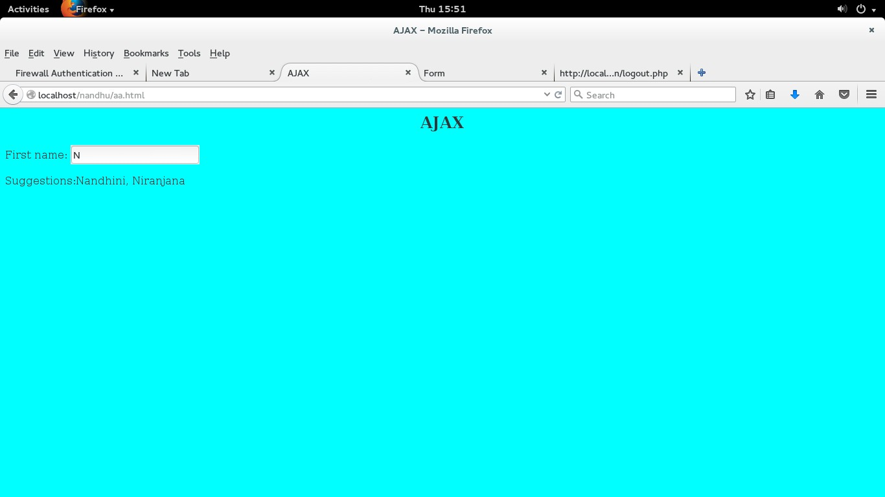

RESULT:

Thus the program to display the matched string using ajax in php was successfully completed and output was verified successfully.

EXP: 8

DATABASE CONNECTIVITY FOR EMPLOYEE DETAILS USING PHP

AIM:
To developing an employee database using PHP.

DESCRIPTION:

      - <style> - Define style information for an HTMLdocument.
      - <?php ?>-php start and endtag
      - Extract()-Imports variables into the local symbol table from an array
      - Die() - Prints a message and exits the currentscript
      - Mysql_connect()-Open a connection to MYSQLserver
      - Mysql_querry() –Execute the given querry and return theresult
      - Mysql_error() -Returns the last error description for the most recent functioncall
      - Mysql_fetch_row()-Fetches one row from aresult-set
      - Mysql_close()-Terminate the connection to mysqlserver

CODING:

<html>
<head>
<title>EMPLOYEE DETAILS</title>
<style type="text/css">body{

}
table{

}
font-family:arial; background-color:cyan;

background-color:pink;

td{ padding-top:2px;
border-style:inset;
padding-left:2px;padding-right:2px; border-width:1px;
}
</style>
</head>
<body>
<?php
extract( $_POST );
//$query = "SELECT * FROM emp";
$query = "SELECT " . $name ." FROMemp";

//$query="INSERT INTO emp(Emp_id,Emp_name,Dob,Designation,Department,Hire_date,Salary)values('102','Sindhu','1 997-07-22','Senior manager','Accounts','2013-02-04','30000')";
//$query="INSERT INTO emp(Emp_id,Emp_name,Dob,Designation,Department,Hire_date,Salary)values('103','SARATHI ','1997-07-25','Senior manager','Accounts','2015-05-04','35000')";
//$query="UPDATE emp SET Designation='senior Sales executive' WHERE emp_id='103'";
//$query="DELETE FROM emp WHERE emp_id='102'";

if( !( $database = mysql_connect( "localhost", "student", "student" ) ) ) die( "could not connect to database </body></html>" );
if( !mysql_select_db( "employee", $database ) )
die( "could not connect to database </body></html>" ); if( !( $result = mysql_query( $query , $database ) ) )
{
print ( "<p>could not execute query</p>" ); die(mysql_error()."</body></html>" );
}
mysql_close( $database );
?>
<table>
<?php
for ( $counter = 0; $row = mysql_fetch_row( $result ); $counter++ )
{
print( "<tr>" );
foreach ( $row as $key => $value ) print( "<td>$value</td>" );
print( "</tr>" );
}
?>
</table>
<br />
search yield <strong><?php print( "$counter" ) ?> results<br /><br /></strong>
</body>
</html> EMPLOYEE
<html>
<head>
<title> EMPLOYE FORM </title>
<style type="text/css"> body
{
background-color:pink;}
</style>
</head>

<body>
<h2 ALIGN="CENTER"><b>EMPLOYEE DETAILS </b></h2>
<form method="post" action="employeedb.php">

<p><b>Select a Field to Display:
<input type="text" name="name" />
<input type="submit" value="Send Query" />
</form>
</body>
</html>

OUTPUT:
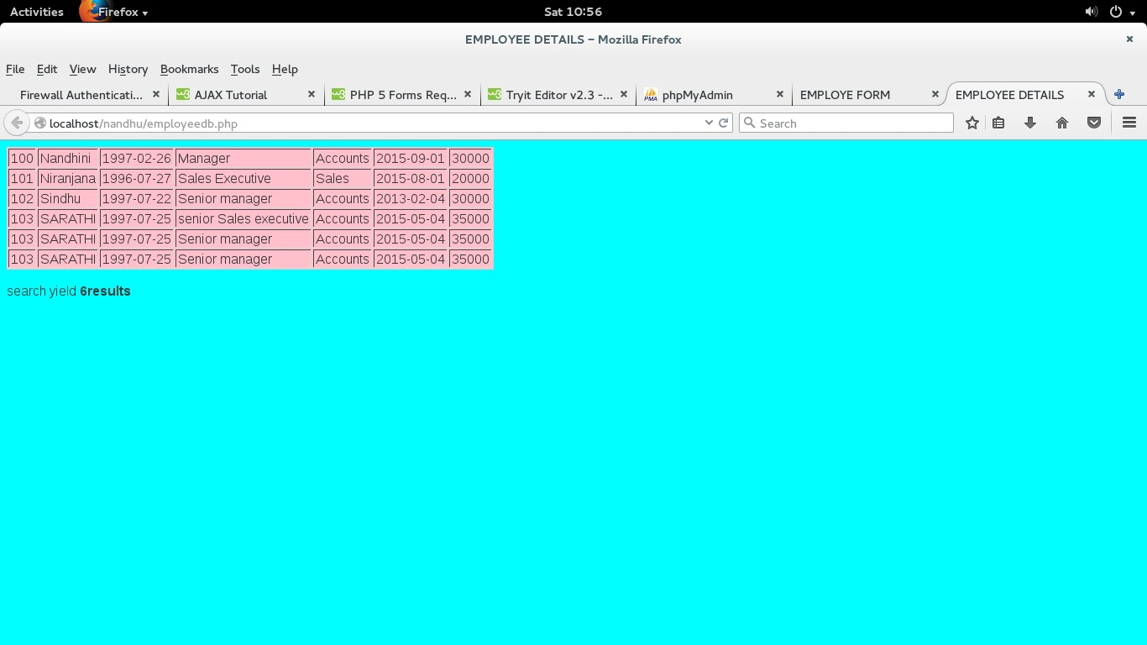

RESULT:
Thus the development of employee database using php was successfully completed and output was verified.

EXP: 9
USER SIGNIN FORM USING SESSION TRACKING

AIM:
To perform registration of user of new user and signin using session tracking

DESCRIPTION:
    - A session is started with the session_start()function.
    - Session variables are set with the PHP global variable:$_SESSION.

CODING:
Index.php
<?php session_start();
if(isset($_POST["LOGIN"]))
{$_SESSION['name']=$_POST['user'];
$_SESSION['password']=$_POST['pass'];
$_SESSION['repassword']=$_POST['word']; header("location: login.php");
}
?>
<?php if(isset($_POST['LOGIN']))
{
$user = $_POST['user'];
$pass = $_POST['pass'];
$word = $_POST['word'];
if($user == $_POST['user'] && $pass == $_POST['pass'] && $word ==
$_POST['word'])
{
$_SESSION['name']=$user;
echo '<script type="text/javascript"> window.open("login.php","_self");</script>';
}
else
{
echo "invalid UserName or Password";
}
}
?>
<html>
<head>
<style> h1{ color:blue;
align=center;}

</style>
<script type='text/javascript'> function validate(field, query)
{
xmlhttp = new XMLHttpRequest(); xmlhttp.onreadystatechange = function()
{
if(xmlhttp.readyState!=4 && xmlhttp.status==200)
{
document.getElementById(field).innerHTML = "Validating..";
}
else if (xmlhttp.readyState==4 && xmlhttp.status==200)
{

}
else
{
document.getElementById(field).innerHTML = xmlhttp.responseText;

document.getElementById(field).innerHTML = "Unknown Error

Occurred. <a href='index.php'>Reload</a> the page.";
}
}
xmlhttp.open("GET","check.php?field="+field+"&query="+query, true); xmlhttp.send();
}
</script>
</head>
<body>
<form action="login.php" method='post'>

<h1><b>REGISTRATION FORM</b></h1>
<table>
<tr>
<td>Username</td>
<td><input type='text' name='user' onchange="validate('u',this.value)"></td>
<td><div id='u'></div></td>
</tr>
<tr>
<td>Password</td>
<td><input type='password' name='pass' onblur="validate('p',this.value)"></td>
<td><div id='p'></div></td></tr>
<tr>
<td>ReType-Password</td>
<td><input type='password' name='word' onblur="validate('r',this.value)"></td>
<td><div id='r'></div></td></tr>
<tr>
<td>Gender</td>

<td><input type='radio' name='gender'value='male' onblur="validate('q',this.value)">Male</td><br>
<td><input type='radio' name='gender' value='female' onblur="validate('q',this.value)">Female</td>
<td><div id='q'></div></td></tr>
<td> E-mail</td>
<td><input type="email" pattern="[a-z0-9._%+-]+@[a-z0-9.-]+\.[a-z]{2,3}$" placeholder="Enter your mail id" required ></td>
</tr>
<tr>
<td> Phone number </td>
<td><input type=tel pattern="[0-9]{10}" placeholder="Enter your phone number" required
></td>
<tr>
<tr>
<td> Address</td>
<td><input type="text" placeholder="Enter your address" required ></td>
</tr>
</table>
<input type='submit' value='CREATE NEW ACCOUNT' >
</form>
</body>
</html>

Check.php
<?php
$query = $_GET['query'];
$field= $_GET['field']; if($field == "u")
{
$username = array("niru", "sacros");

if(in_array($query, $username))
echo "<font color=red>Username already exists</font>"; else
echo "<font color=green>Username is valid</font>";
}
else if($field == "p")
{
if(strlen($query) < 6)
echo "<font color=red>Password too short</font>"; else
echo "<font color=green>password is valid</font>";
}
else if($field == "m")
{
if(!preg_match("/([\w\-]+\@[\w\-]+\.[\w\-]+)/",$query))
echo"<font color=red>invalid email</font>"; else
echo"<font color=green>valid</font>";
}
else if($field =="n")
{
if (!preg_match("/\b(?:(?:https?|ftp):\/\/|www\.)[-a-z0-9+&@#\/%?=~_|!:,.;]*[-a-z0- 9+&@#\/%=~_|]/i", $query))
echo"<font color=red>invalid website</font>"; else
echo"<font color=green>valid</font>";
}
?>

Login.php
<?php
session_start();
?>
<?php
if(isset($_POST['LOGIN']))
{
$user=$_POST['user'];
$pass=$_POST['pass'];

if($user == $_POST['user'] && $pass == $_POST['pass'])
{
$_SESSION['name']=$user;

echo '<script type="text/javascript">window.open("profile.php","_self");
</script>';
}
else
{
echo "invalid";
}
}
?>
<html>
<head>
</head>
<body>
<h1>LOGIN FORM</h1>
<form method="POST">
<b>Name:</b><br><input type=text name="user" required /><br>
<b>Password:</b><br><input type=password name="pass" required /><br>
<b>RePassword:</b><br><input type=password name="word" required /><br>
<button type="submit" name="LOGIN">Submit</button>
</form>
</body>
</html>

Logout.php
<?php session_start(); print_r($_SESSION);
if(isset($_SESSION['name']))
{
unset($_SESSION['name']);
}
echo '<h1>You have been successfully logout</h1>';
?>
<html>
<head>
<h1><?php echo $name;?></h1>
<h3><a href="login.php">Click here to go back..</a></h3>
</html>

Profile.php
<?php
session_start(); if(!isset($_SESSION['name']))
{
header("location: index.php");
}
$name=$_SESSION['name'];
?>
<html>
<head>
<title>Welcome <?php echo $name;?></title>
</head>
<h1>Hi.......<?php echo $name;?></h1>
<img src="index.jpg">
<h3><a href="logout.php">Click Here to log out</a></h3>
</html>

OUTPUT:
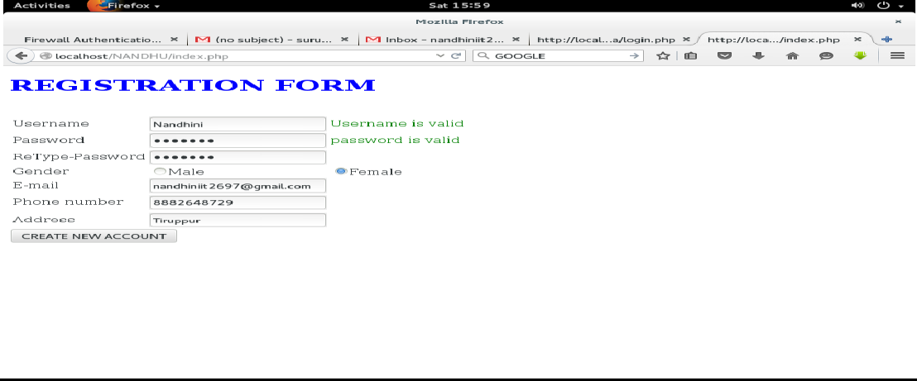

RESULT:
Thus the program to perform registration form validation login logout process using session tracking concept was successfully completed and output was verified.
EXP:10

DEVELOPING ONLINE RESERVATION SYSTEM USING JAVASCRIPT, CSS, AJAX, PHP,MYSQL WITH SESSION TRACKING

AIM:

To design and display online reservation system using javascript,css,ajax,php,mysql with session tracking.

DESCRIPTION:
    - $_SERVER["PHP_SELF"] - The $_SERVER["PHP_SELF"] is a super globalvariable that returns the filename of the currently executingscript.

Open a Connection to the MySQLServer
mysqli_connect(host,username,password,dbname);

Close aConnection
mysqli_close($con);

LOGIN:
<html>
<body>
<form action="login.php" method="post"> User name:
<input type="text" name="name"> Password:
<input type="text" name="pw">
<br>
<input type="submit" value="submit">
</form>
</body>
</html>

INSERT:
<html>
<body>
<form method="post" action="insert.php"><br> rollno:
<input type="text" name="rollno"><br> name:
<input type="text"name="name"><br> m1:
<input type="text"name="m1"><br> m2:
<input type="text"name="m2"><br> m3:
<input type="text" name="m3"><br>m4:
<input type="text"name="m4"><br> m5:
<input type="text"name="m5"><br> m6:
<input type="text" name="m6"><br>
<input type="submit" value="submit">
</form>
</body>
</html>

INDEX:
<html>
<head>
<style> body
{background-color:"yellow";} table
{
margin:2em;
border-color:"black";
}
</style>
<script type='text/javascript'> function validate(field, query)
{
xmlhttp = new XMLHttpRequest();

xmlhttp.onreadystatechange = function()
{
if (xmlhttp.readyState!=4 && xmlhttp.status==200)
{
document.getElementById(field).innerHTML = "Validating..";
}
else if (xmlhttp.readyState==4 && xmlhttp.status==200)
{
document.getElementById(field).innerHTML = xmlhttp.responseText;
}
else
{
document.getElementById(field).innerHTML ="UnknownError Occurred.<a href='index.php'>Reload</a> thepage.";
}
}
xmlhttp.open("GET","check.php?field="+field+"&query="+query, false); xmlhttp.send();
}
</script>
</head>
<body bgcolor="grey">
<h2 font-color="red"><marquee><u><i>REGISTRATION FORM</i></u></marquee></h2>
<form action="submitted.html" method='post' font color="white" >
<table>
<tr>
<td>Username</td>
<td><input type='text' name='user' onchange="validate('u',this.value)"></td>
<td><div id='u'></div></td>
</tr>
<tr>
<td>Password</td>
<td><input type='password' name='pass' onblur="validate('p',this.value)"></td>
<td><divid='p'></div></td> </tr>
<tr>
<td>phone number</td>
<td><input type='text' name='phone' onblur="validate('ph',this.value)"></td>
<td><divid='ph'></div></td> </tr>
<tr>
<td>gender</td>
<td><input type='radio' name='gender' onblur="validate('male',this.value)"></td>
<td><div id='male'></div></td>
<td><input type='radio' name='gender' onblur="validate('female',this.value)"></td>
<td><divid='female'></div></td> </tr>
<tr>
<td>qualificaton</td>
<td><input type='text' name='q' onblur="validate('q',this.value)"></td>
<td><divid='q'></div></td> </tr>
<tr>
<td>university</td>
<td><input type='text' name='un' onblur="validate('un',this.value)"></td>
<td><div id='un'></div></td></tr><br><p>//enter the country name as 'India'</p>
<tr>
<td>country</td>
<td><input type='text' name='c' onblur="validate('c',this.value)"></td>
<td><div id='c'></div></td></tr>
</table>
<input type='submit' value='Submit'>
</form>
</body>
</html>

FETCH:
<?php
function grade($var)
{
if($var>=90)
{
$g="S";
}
if($var<=89 && $var>=80){
$g="A";}
if($var<=79 && $var>=70){
$g="B";}
if($var<=69 && $var>=60){
$g="C";}
if($var<=59 && $var>=55){
$g="D";}
if($var<=54 && $var>=50){
$g="E";}
if($var<50){
$g="RA";}
return$g;
}
$con =mysql_connect("localhost","student","student"); if(!$con)
{
die('could not connect : '.mysql_error());
}
mysql_select_db("db1",$con);
$r=$_POST['rollno'];
$result=mysql_query("SELECT * FROM mark where rollno='$r'");

while($row = mysql_fetch_array($result))
{
echo '<table border=1px>
<tr>STUDENT MARK DETAILS</tr>

<tr><td>ROLL</td><tdcolspan=2>'.$row['rollno'].'</td></tr>
<tr><td>NAME</td><tdcolspan=2>'.$row['name'].'</td></tr>
<tr><td>Mark1</td><td>'.$row['m1'].'</td><td>'.grade($row['m1']).'</td></tr>
<tr><td>Mark1</td><td>'.$row['m2'].'</td><td>'.grade($row['m2']).'</td></tr>
<tr><td>Mark2</td><td>'.$row['m3'].'</td><td>'.grade($row['m3']).'</td></tr>
<tr><td>Mark4</td><td>'.$row['m4'].'</td><td>'.grade($row['m4']).'</td></tr>
<tr><td>Mark5</td><td>'.$row['m5'].'</td><td>'.grade($row['m5']).'</td></tr>
<tr><td>Mark6</td><td>'.$row['m6'].'</td><td>'.grade($row['m6']).'</td></tr>
</table>';
}
mysql_close($con);
?>

UPDATE:
<html>
<?php session_start();$hi=$_SESSION['login']; echo $hi;
?>
<body>
<form method="post"action="update.php"> Roll no:
<input type="text"name="name"><br> m1:
<input type="text"name="m1"><br> m2:
<input type="text"name="m2"><br> m3:
<input type="text" name="m3"><br>
<input type="submit" value="submit">
</form>
</body>
</html>

DELETE:
<?php
$v1=$_POST['rollno'];
$v2=$_POST['name'];
$v3=$_POST['m1'];
$v4=$_POST['m2'];
$v5=$_POST['m3'];
$v6=$_POST['m4'];
$v7=$_POST['m5'];
$v8=$_POST['m6'];
$con=mysql_connect("localhost","student","student"); mysql_select_db("mark",$con);
$query="DELETE FROM mark WHERE rollno='$v1';"; mysql_query($query,$con);
echo "delete successfully"; mysql_close($con);
?>

<html>
<body> session_start();
<form action="fetch.php" method="post"> ROLL NO:
<input type="text" name="rollno">
<input type="submit" value="submit">
</form>
</body>
</html>

SESSION:
<?
session_start();

$server = "localhost";
$username ="Santhosh";
$password ="Santhosh";
$db_name = "stud_db";

$db = mysql_connect($server,$username,$password) or die("Connection to database failed, perhaps the service is down !!");
mysql_select_db($db_name) or die("Database name not available !!");

$login = mysql_query("select * from users where (username = '" . $_POST['username'] . "') and (password = '" .md5($_POST['password']) . "')",$db);
$rowcount = mysql_num_rows($login); if ($rowcount == 1) {
$_SESSION['username'] = $_POST['username']; header("Location: securedpage.php");
}
else
{
header("Location: loginpage.php");
}
?>

PAGE:
<?php session_start();
$temp=$_SESSION['login']; echo "WELCOME<br>".$temp;
echo "<a href=insert.html>INSERT</a><br>"; echo "<a href=update.html>UPDATE</a><br>"; echo "<a href=delete.html>DELETE</a><br>"; echo "<a href=result.html>SELECT</a><br>"; echo "<a href=logout.php>LOGOUT</a><br>";
?>

OUTPUT:
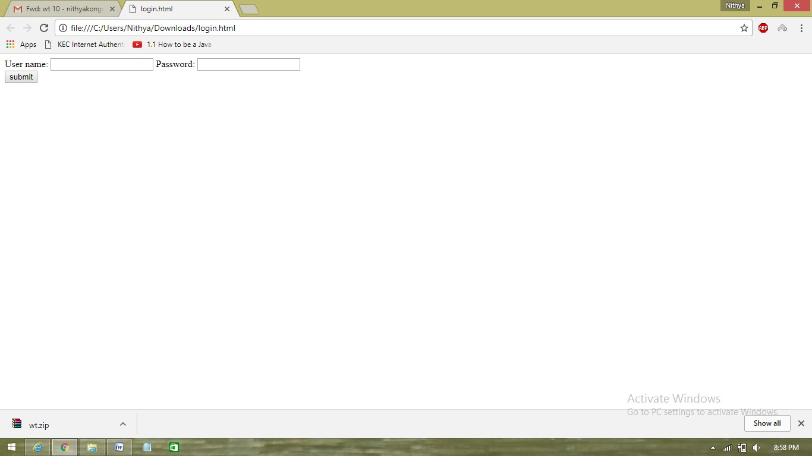

RESULT:
Thus the implementation of online reservation system usingjavascript,css,ajax,php,mysql with session tracking was implemented and output was verified

Content beyond syllabus
Creation of XML document and validate using DTD for Book Store

AIM:
To create XML document and validate using DTD for Book Store

DESCRIPTION:
    - XML documents must have a rootelement
    - XML elements must have a closingtag
    - XML tags are casesensitive
    - XML elements must be properlynested
    - XML attribute values must bequoted
    - XML DTD: The purpose of a DTD is to define the structure of an XML document. It defines the structure with a list of legalelements

CODING:
<!DOCTYPE bookstore [
<!ELEMENT bookstore (book+)>
<!ELEMENT book (title,author,ISBN,publisher,edition,price)>
<!ELEMENT title (#PCDATA)>
<!ELEMENT author (#PCDATA)>
<!ELEMENT ISBN (#PCDATA)>
<!ELEMENT publisher (#PCDATA)>
<!ELEMENT edition (#PCDATA)>
<!ELEMENT price (#PCDATA)>
]>
<bookstore>
<book>
<title>internet worldwideweb</title>
<author>ditel&amp;ditel</author>
<ISBN>123-456-781</ISBN>
<publisher>person</publisher>
<edition>3</edition>
<price>450</price>
</book>
</bookstore>

OUTPUT:
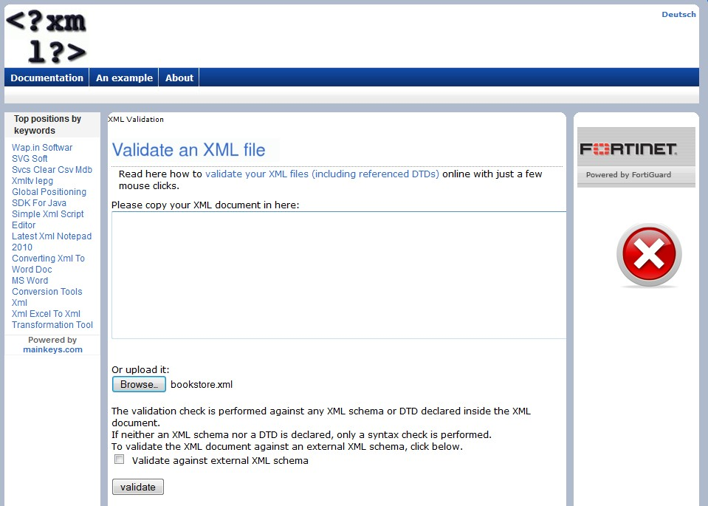

RESULT:
Thus XML document is created and validated using DTD for Book Store

